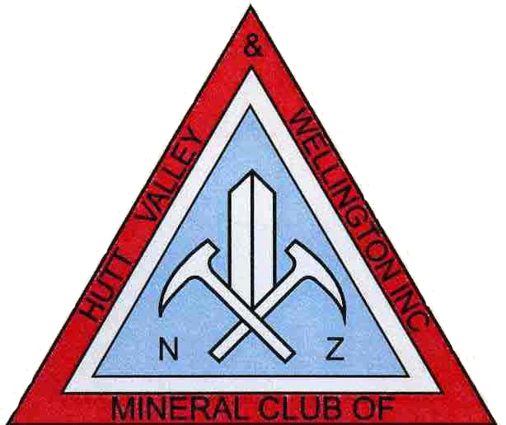 Frequently Asked Questions

Who can join?
Anyone interested in our hobby older than 5 years old (we have a separate junior group).

Can I drop off my child for the junior group meeting?
No all children must be accompanied by an adult caregiver, e.g. at least one adult would have to be present for their (say 2 -3 children. Adults accompanying children could for example help with the activities, make use of the library.

Should I advise health problems?
While that is up to the individual, the committee should be made aware of any member’s health issues in the event that help is required (e.g. diabetes, wasp sting allergy, fainting, serious communicable disease etc).

What’s the workshop for?
The club provides the workshop for members use. Once a member has been through the workshop introduction (learning the effective and safe use of the equipment) it is made available at the advertised times.

Can a key be made available so I can use the workshop at my leisure?
As a general rule you cannot! There are currently 2 workshop sessions per month. The club deems this adequate.

Can I make a suggestion?
Yes, by all means. The committee always welcomes feedback and we do have a suggestion box in the clubrooms.

Does the club have a constitution?
Yes, it is available from the committee to all current financial members on request

Can I come to see what the club is about without commitment?
Yes of course. This is an opportunity to see the facilities the club provides.
However, to participate in any activities such as workshop, auctions etc we’d like you to be a paid member

I am changing my address. What shall I do?
Please advise the club of your new address.

I can’t come always. Is this OK?
Yes of course, although if you are expected, then you should contact the club either by e-mail, telephone or passing on a message.

How long is my membership valid?
Paid memberships are valid as per the issued receipt. Membership should be renewed on an annual basis after the AGM (usually May)

What happens if I let my membership lapse?
You will continue to get the newsletter (MAGMA) for a while, but only until the committee decides that enough time had been provided to renew the membership.

Do I need to apply for membership again if I have not been a member for a while?
Please check with the committee if the details are still on file.

Does the club cut or work stones on behalf?
No it doesn’t! If you join the club you can learn how to do it yourself or find another member who may be prepared to do it for you.

Does the club trade in rocks, gemstones and fossils?
No, the club is a non-profit organisation and as such doesn’t trade in materials. There are however fundraising auctions from time to time. Contact the committee if you have something to contribute.

What is the ‘supper donation’ for?
It is a voluntary donation (suggested 50 cents/person) that is used to help pay the monthly power bill

What does the workshop night cost?
We expect a ‘gold coin donation’ for the purpose of equipment use/maintenance

Does the workshop night donation include use of the big saw?
No, there is a separate cost (set by the committee) depending on cutting time.

Why is the big saw locked?
The club has decided that only workshop supervisors operate the large saw (on 3rd Wednesday workshop nights) taking into consideration what and how to cut the piece – for members only.

When are the club meetings?
2nd Wednesday of the month Interest night Starts 8 pm
2nd Sunday of the month Junior Group 10 am to 2pm (bring lunch)
3rd Wednesday of the month Workshop night 7:30 pm (booking essential)
3rd Sunday of the month Field trip As advertised
4th Wednesday of the month Guest speaker Starts 8 pm

For the monthly program check out ‘What’s on’ ‘Local’ on the website.

What’s the Micro Mineral Group?
Those interested in the wonderful world on microscopic minerals meet on the 1st Tuesday of the month at Victoria University where microscopes can be used, to look at micro minerals. However, while attended by some club members (as well as others) it is not actually part of the club. There is an affordable subscription charge for the newsletter (MICROSCOPE). People subscribing to this newsletter are in NZ, Australia as well as other parts of the world. There is an annual NZ Micro mineral symposium attended by Micro mounters from NZ, Australia and usually also from overeas.

